**SQL Assignment: **

Q.1) The following schemas contain tables related to sales and production of a Fashion chain. Write SQL queries for the given problem statements below.

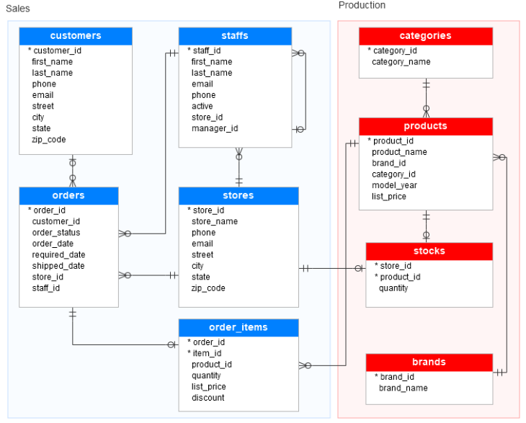

1. Write a query to return number of unique customers from the state of Karnataka

**Columns required: state_name, customers**

1. Write a query to show the name of the state with second highest number of stores available to customers

**Columns required: state_name, stores**

1. Write a query to show 10 worst performing staff based on commission earned, where commission earned is 15% of total order value (Order value to be calculated as product of quantity and list price with discount subtracted from the total)

**Columns required: staff_id, orders_sold, commission_earned**

1. Write a query to show the number of orders per category where there has been a delay of over 1 week between order purchased to shipped

**Columns required: category_name, orders**

1. Write a query to return customer id, and the first and last name as a single string for the top 3 customers by single order value (Order value to be calculated as product of quantity and list price with discount subtracted from the total). In the same view also show the next highest purchase made by the customer

**Columns required: customer_id, full_name, highest_purchase, second_highest_purchase**

**Q2)**. Given an **Order Table** with the Schema **(id, user_id, created_at, amount**). Write a SQL Query to extract the raw data to create a **retention plot**. The format for the raw data and output is given.

Week Start Date is the 1st Week in which the User_Id Placed the order, Week 0 is Unique User ids who placed their 1st Order in this week. Out of those ids, Week 1 is unique users who placed an order in 1st Week + 1, Then Week 2 is 1st Week + 2, and so on till Week 10.

**Raw Data:**

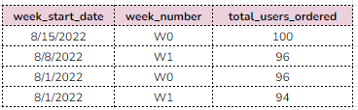

**Output Table:**

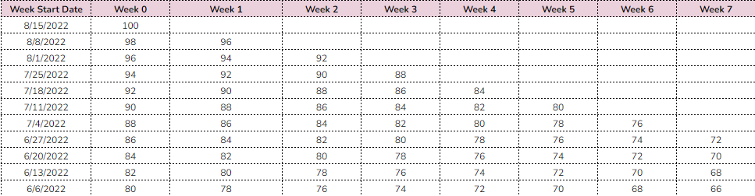

**Q3)** A company records its employee's movement **In and Out** of the office on a table with 3 columns. There is NO sample data for this question. You only need to submit the queries

Schema: **(employee_id, action (In/Out), created_at)**

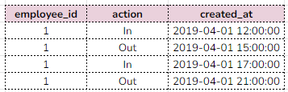

**The first entry for each employee is “In”

**Every “In” is succeeded by an “Out”

**No data gaps and, the employee can work across days

a.) Find the number of employees inside the Office at “2019-06-01 15:05:00”

b.) Measure the number of hours spent by each employee inside the office since the day they started (Account for a current shift if she/he is working)

c.) Measure the number of hours spent by each employee inside the office between “2019-04-01 15:00:00” and “2019-04-04 11:00:00”